SEMESTER 1
SEMESTER 1
ELECTRONICS FUNDAMENTALS: ANALOG, DIGITAL
AND SENSOR INTERFACING


Module Overview
This module builds a complete theoretical foundation in electronics, starting from the basic quantities of voltage and current and ending with a complete sensing-and-control system. It covers the passive components every circuit depends on (resistors and capacitors), the two great families of electronics (analog and digital), sensors as analog devices, the analog-to-digital converter (ADC) that connects the physical world to software, and the switching devices (transistors and relays) that let a small control signal drive a real load. The topics are organised as self-contained sections that build on each other, so every concept introduced later rests on those explained earlier.
Throughout the module, one system is used as the connecting thread: a Smart Sensor Node that senses light and temperature, converts them into numbers, makes a decision, and switches a fan or lamp. Each section explains one stage of that system.
# | Topic | Key Concepts
1 | Introduction to Electronics | Sense–Convert–Decide–Act model, analog vs digital, schematics
2 | Voltage, Current, Resistors & the Voltage Divider | Ohm's law, power, KVL/KCL, series/parallel, divider
3 | Capacitors | Charge storage, RC time constant, filtering, debouncing
4 | Digital Electronics | Binary, logic levels, logic gates, Boolean logic
5 | Analog Electronics & Sensors as Analog Devices | Diodes, LEDs, LDR, NTC thermistor, TMP36, calibration
6 | The ADC Concept | Sampling, quantisation, resolution, V_ref, noise
7 | Transistors | BJT and MOSFET as switches, PWM
8 | Relays | Electromagnetic switching, isolation, flyback diode
9 | Bringing It Together: The Smart Sensor Node | System integration, hysteresis, Edge AI link

1. Introduction to Electronics

1.1 What Is Electronics?
Electronics is the branch of engineering that uses the controlled movement of electric charge to process energy and information. A simple electric circuit, such as a torch, only delivers energy from a battery to a bulb. An electronic circuit goes further: it measures, decides, amplifies, stores, or switches, using components such as transistors, capacitors, sensors, and integrated circuits.
Electronics is commonly divided into two families. Analog electronics deals with quantities that vary continuously, such as the voltage from a microphone or a temperature sensor. Digital electronics deals with information represented by only two states, 1 and 0. Almost every modern product combines both: the real world is analog, while computation is digital.

1.2 The Sense–Convert–Decide–Act Model
Nearly every electronic product, from a thermostat to a self-driving car, can be understood as four stages connected in a chain:
- Sense — a sensor converts a physical quantity (light, heat, pressure, sound) into an electrical signal, usually a voltage.
- Convert — an analog-to-digital converter (ADC) turns that voltage into a number a processor can work with.
- Decide — digital logic or a microcontroller compares the number against rules and decides what to do.
- Act — a transistor or relay switches a load (a motor, fan, lamp or buzzer) that changes the physical world.
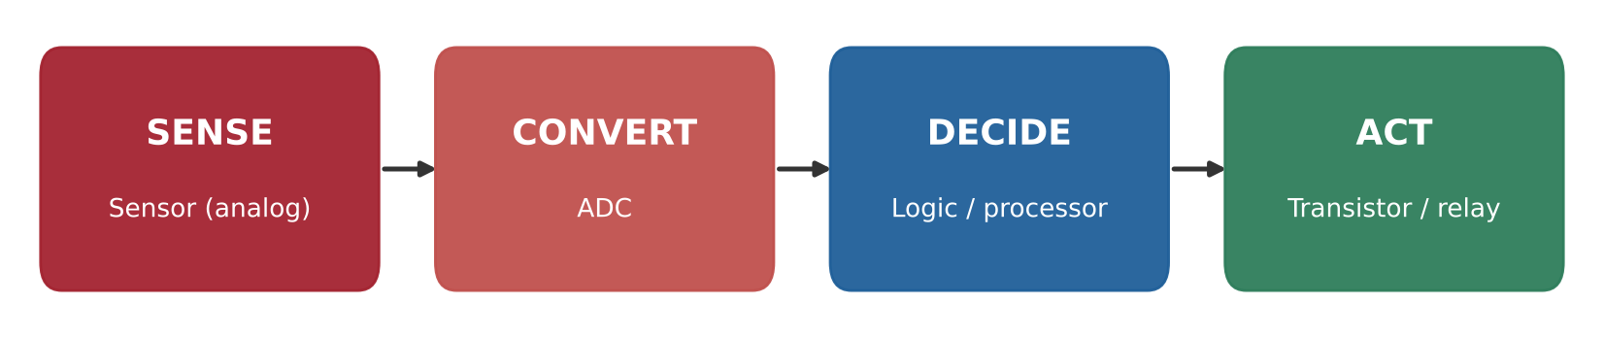
Figure 1.1: The Sense–Convert–Decide–Act chain found in almost every electronic system.

For example, a phone's automatic brightness feature senses ambient light with a photodiode, converts it with an ADC, decides on a screen brightness in software, and acts by changing the backlight current. A digital camera follows the same chain, except that its sensor contains millions of light-sensing elements arranged in a grid.

1.3 Reading a Circuit Schematic
A schematic is the standard language for describing a circuit. It shows which components are connected, not where they physically sit on a board. Lines represent wires; a dot where lines meet means they are joined; lines that cross without a dot are not connected. Ground (0 V) is the common reference point against which all other voltages are measured.
Symbol / Component | Function | Unit
Battery / DC source | Provides a fixed voltage | Volt (V)
Resistor | Limits current, sets voltages | Ohm (Ω)
Capacitor | Stores charge, smooths and times signals | Farad (F)
Diode / LED | Allows current in one direction; LED emits light | —
Transistor (BJT / MOSFET) | Electronic switch or amplifier | —
Relay | Electromagnetically operated switch | —
Ground | 0 V reference for the whole circuit | —

1.4 Safety Principles
- Work only with low-voltage DC (12 V or less) in a learning environment; mains voltage can be lethal.
- Never connect a supply's positive and negative terminals directly together (a short circuit).
- Always power down before changing connections or measuring resistance.
- Respect component polarity and ratings; electrolytic capacitors and LEDs connected backwards can fail.

2. Voltage, Current, Resistors & the Voltage Divider

2.1 Charge, Voltage and Current
Current (I) is the rate at which electric charge flows past a point, measured in amperes (A). One ampere is one coulomb of charge per second; small currents are expressed in milliamperes (mA). In a single closed loop, the same current flows through every component.
Voltage (V) is the difference in electrical potential energy between two points, measured in volts (V). It is the "push" that drives current. Voltage is always measured between two points, usually between a node and ground.
A useful analogy is a water system: voltage is the height of a water tank (pressure), current is the flow rate in the pipe, and resistance is a narrowing of the pipe that restricts the flow.

2.2 Ohm's Law and Power
Ohm's law states that the current through a resistor is proportional to the voltage across it. It is the single most used relationship in electronics:
V = I × R I = V / R R = V / I
Electrical power is the rate at which energy is converted, for example into heat or light. In a resistor, it becomes heat, which is why every resistor has a power rating (commonly ¼ W).
P = V × I = I² × R = V² / R
For example, a 5 V USB port supplying 0.5 A delivers 2.5 W. If 3.3 V appears across a 1 kΩ resistor, the current is 3.3 mA, and the power dissipated is about 11 mW, well within a ¼ W rating.
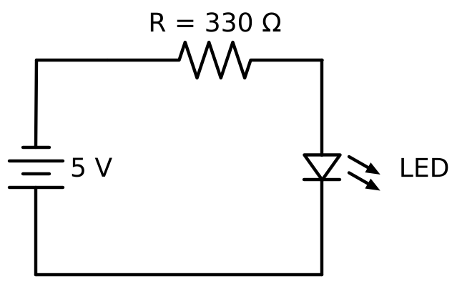
Figure 2.1: A basic circuit: a 5 V source, a 330 Ω current-limiting resistor and an LED.

2.3 Resistors
A resistor is a passive component that opposes current. Resistors are used to limit current (for example, through an LED), to create specific voltages, to set the default state of a digital input (pull-up and pull-down resistors), and to protect sensitive pins.
- Value — resistors are manufactured in standard series. The E12 series uses 1.0, 1.2, 1.5, 1.8, 2.2, 2.7, 3.3, 3.9, 4.7, 5.6, 6.8, and 8.2, multiplied by powers of ten.
- Tolerance — the allowed deviation from the printed value, typically ±1% or ±5%. This is why a measured value rarely matches the printed value exactly.
- Power rating — the maximum heat the resistor can safely dissipate (⅛ W, ¼ W, ½ W and above).
- Colour code — through-hole resistors are marked with coloured bands giving two significant digits, a multiplier and a tolerance band.
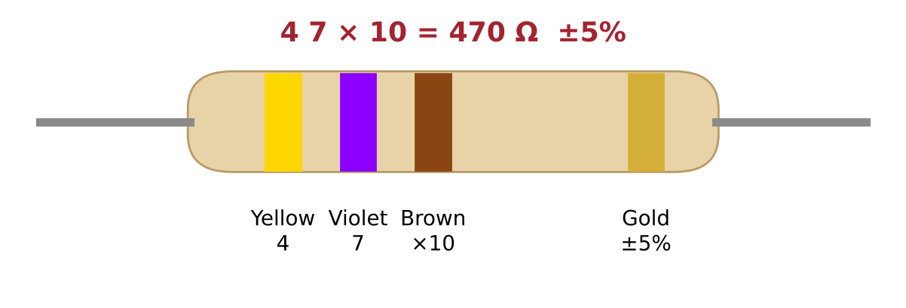
Figure 2.2: Reading the colour code of a four-band resistor: yellow, violet, brown, gold = 470 Ω ±5%.
Colour | Digit | Multiplier | Colour | Digit | Multiplier
Black | 0 | ×1 | Green | 5 | ×100 k
Brown | 1 | ×10 | Blue | 6 | ×1 M
Red | 2 | ×100 | Violet | 7 | —
Orange | 3 | ×1 k | Grey | 8 | —
Yellow | 4 | ×10 k | White | 9 | —

Worked example — LED current-limiting resistor. A red LED drops about 2.0 V and should carry 10 mA from a 5 V supply. The resistor must drop the remaining 3.0 V, so R = (5 − 2.0) / 0.010 = 300 Ω. Because exactly 300 Ω is not a standard value, the next higher E12 value, 330 Ω, is chosen, giving about 9 mA.

2.4 Series and Parallel Circuits, KVL and KCL
Resistors connected end to end are in series: the same current flows through each, and their resistances add. Resistors connected across the same two nodes are in parallel: they share the same voltage, and the equivalent resistance is always smaller than the smallest individual resistor.
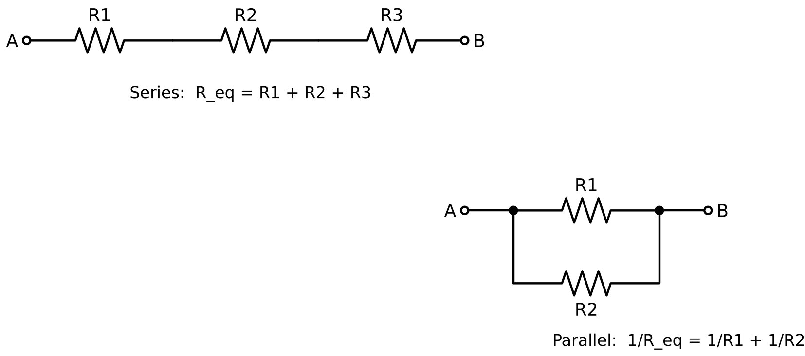
Figure 2.3: Series and parallel resistor connections and their equivalent resistance.
Two laws, published by Gustav Kirchhoff, allow any resistor network to be analysed:
- Kirchhoff's Current Law (KCL) — the total current flowing into a node equals the total current flowing out. Charge is not created or lost at a junction.
- Kirchhoff's Voltage Law (KVL) — the sum of all voltage rises and drops around any closed loop is zero. The source voltage is shared among the components in the loop.

2.5 The Voltage Divider
A voltage divider is two resistors in series across a supply. The voltage at the junction between them is a fixed fraction of the input, set by the ratio of the resistors. This simple circuit is one of the most important in electronics: it creates reference voltages, scales large voltages down to safe levels, and, as Section 5 shows, is the standard way of connecting resistive sensors.
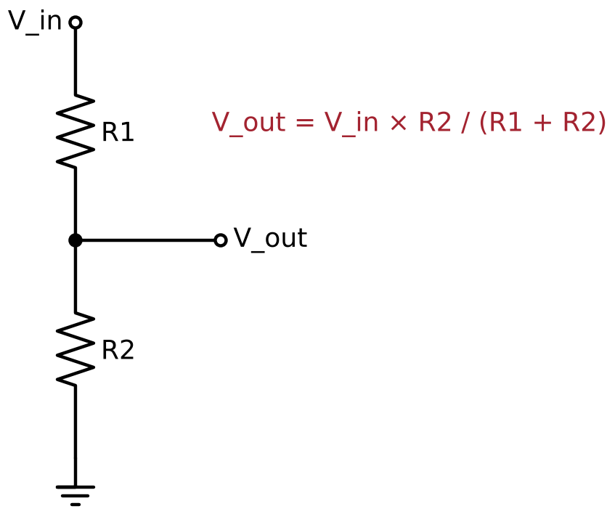
Figure 2.4: The voltage divider and its output equation.
When R1 equals R2, the output is exactly half the input. A 10 kΩ and 20 kΩ pair converts 5 V into about 3.33 V, which is suitable for a 3.3 V logic input. A divider is not a power supply: any load connected to V_out appears in parallel with R2 and pulls the output down. As a rule, the load resistance should be at least ten times R2.
Lab Exercise 1: Verifying Ohm's Law and Designing a Voltage Divider
Objective
To verify the relationship between voltage, current, and resistance, and to design a voltage divider that produces a required output voltage using standard E12 resistor values.
Components Required
- Breadboard and jumper wires
- 5 V DC supply (USB or bench supply)
- Resistors: 330 Ω, 1 kΩ, 2.2 kΩ, 4.7 kΩ, 10 kΩ, 20 kΩ
- Digital multimeter
Working Principle
According to Ohm's law, the current through a resistor equals the voltage across it divided by its resistance. When two resistors are connected in series across a supply, the same current flows through both, and the supply voltage divides between them in proportion to their resistances. Comparing calculated values with measured values reveals the effect of component tolerance and meter accuracy.

Procedure
- Calculate the expected current for each resistor connected across 5 V and record it in the observation table.
- Connect each resistor in turn across the 5 V supply and measure the voltage across it with the multimeter.
- Calculate the measured current as I = V / R and compare it with the predicted value.
- Design a divider to produce approximately 3.3 V from 5 V and calculate its expected output.
- Build the divider using 10 kΩ (R1) and 20 kΩ (R2) and measure V_out.
- Calculate the percentage error between predicted and measured values.
Observation Table
Resistor | Predicted Current (mA) | Measured Voltage (V) | Measured Current (mA) | % Error
330 Ω | 15.2
1 kΩ | 5.0
4.7 kΩ | 1.06
10 kΩ | 0.50
Divider 10 k / 20 k | V_out = 3.33 V |  | —

Expected Output
Measured currents should agree with predicted values within about 5%, the tolerance of standard resistors. The divider output should be close to 3.33 V. Small differences are explained by resistor tolerance and the exact supply voltage.
Conclusion
This activity confirms Ohm's law experimentally and shows how a voltage divider sets an output voltage by resistor ratio, forming the basis of the sensor interfaces studied in Section 5.

3. Capacitors

3.1 What Is a Capacitor?
A capacitor is a passive component that stores electric charge. It consists of two conducting plates separated by an insulating material called the dielectric. When a voltage is applied, positive charge builds up on one plate and an equal negative charge on the other. No current flows through the dielectric; current flows only while the capacitor is charging or discharging.
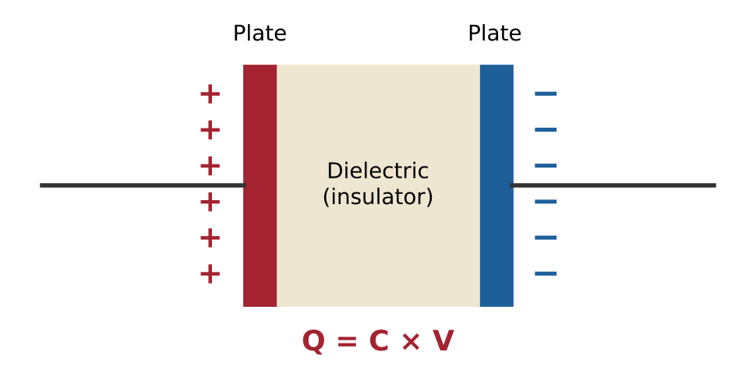
Figure 3.1: Basic structure of a capacitor: two plates separated by a dielectric. The stored charge is Q = C × V.
Capacitance (C) is measured in farads (F). Practical values are much smaller: microfarads (µF), nanofarads (nF) and picofarads (pF). A capacitor also has a maximum voltage rating, which should be comfortably above the circuit voltage, ideally twice it.
Type | Typical Range | Polarised? | Typical Use
Ceramic | 1 pF – 10 µF | No | Decoupling, filtering, timing
Electrolytic (aluminium) | 1 µF – 10,000 µF | Yes | Power-supply smoothing, bulk storage
Tantalum | 0.1 µF – 1000 µF | Yes | Compact, stable bulk capacitance
Film | 1 nF – 100 µF | No | Audio, precision timing

Ceramic capacitors are usually marked with a three-digit code: two significant digits followed by the number of zeros, in picofarads. For example, "104" means 10 followed by four zeros = 100,000 pF = 100 nF.

3.2 RC Charging and the Time Constant
When a capacitor charges through a resistor, its voltage does not jump instantly. It rises quickly at first and then more slowly as it approaches the supply voltage. The speed is set by the time constant, τ (tau):
τ = R × C V(t) = Vs (1 − e^(−t/τ))
After one time constant, the capacitor reaches about 63% of the supply voltage; after five time constants, it is more than 99% charged and is considered fully charged. Discharge follows the mirror-image curve. With R = 10 kΩ and C = 100 µF, τ = 1 second.
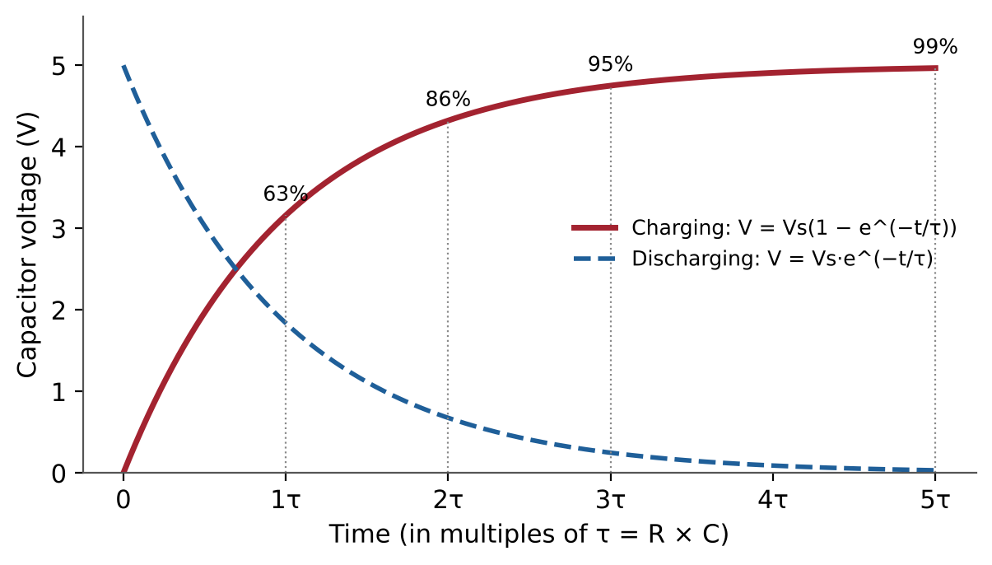
Figure 3.2: Charging and discharging curves of an RC circuit, marked in multiples of the time constant.

3.3 Filtering and Decoupling
Because a capacitor resists sudden changes in voltage, a resistor and capacitor together form a low-pass filter: slow changes pass through, while fast changes such as electrical noise are smoothed out. The boundary between "slow" and "fast" is the cut-off frequency:
f_c = 1 / (2π × R × C)
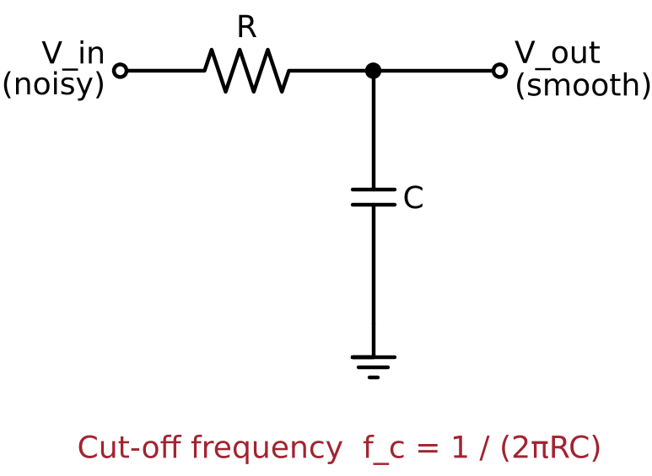
Figure 3.3: An RC low-pass filter.
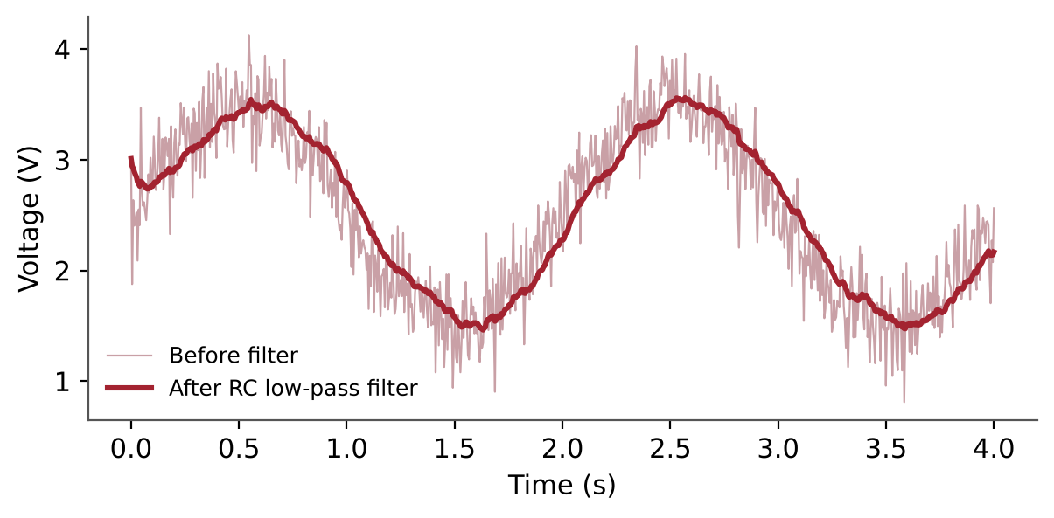
Figure 3.4: A noisy sensor signal before and after RC low-pass filtering.
A 10 kΩ resistor with a 1 µF capacitor gives a cut-off of about 16 Hz, which removes electrical noise while still following a slowly changing sensor. A related use is decoupling: a 100 nF capacitor placed close to the power pins of every integrated circuit supplies the short bursts of current the chip draws, preventing voltage dips that cause erratic behaviour.

3.4 Switch Bounce and Debouncing
When a mechanical push button is pressed, its metal contacts physically bounce for roughly 1–20 ms before settling. A digital input sees several rapid on-off transitions, so a single press may be counted many times. This is called switch bounce.
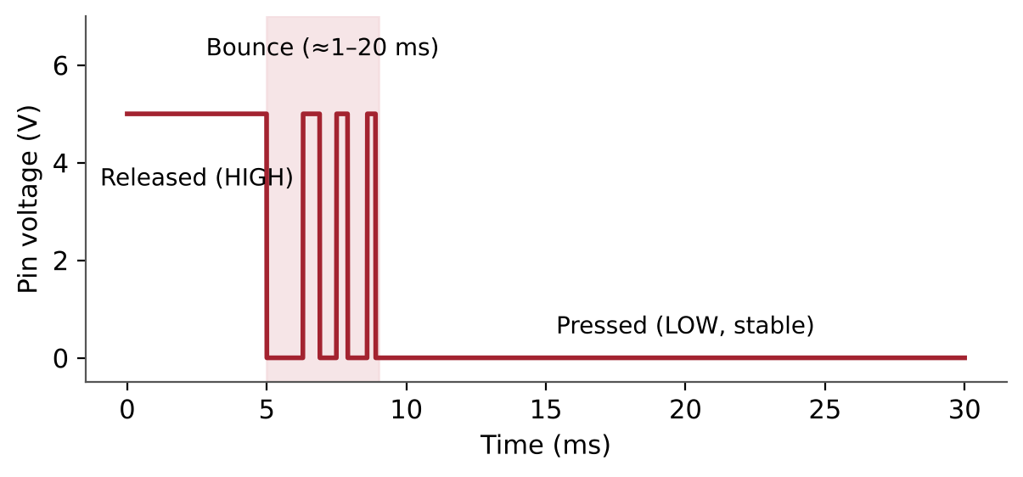
Figure 3.5: Contact bounce at the moment a push button is pressed.
- Hardware debouncing — an RC filter (for example, 10 kΩ and 100 nF) smooths the bounces into a single clean transition.
- Software debouncing — the processor ignores further changes for a short period (about 20–50 ms) after the first transition.
Lab Exercise 2: Observing RC Charging and the Time Constant
Objective
To observe the charging behaviour of a capacitor through a resistor and to compare the measured time constant with the theoretical value τ = R × C.
Components Required
- 10 kΩ resistor and 100 µF electrolytic capacitor
- 5 V DC supply and a push-button or switch
- Digital multimeter and stopwatch (or a microcontroller with an analog input)
Working Principle
When a discharged capacitor is connected to a supply through a resistor, the capacitor voltage rises exponentially. The time taken to reach 63% of the supply voltage is the time constant, which depends only on the product of resistance and capacitance.
Procedure
- Calculate the theoretical time constant: τ = 10 kΩ × 100 µF = 1 s.
- Make sure the capacitor is fully discharged and check its polarity before connecting it.
- Connect the resistor and capacitor in series and switch on the 5 V supply.
- Record the capacitor voltage at regular intervals (for example every 0.5 s) for 5 seconds.
- Plot voltage against time and find the time at which the voltage reaches about 3.16 V (63% of 5 V).
- Compare the measured time constant with the theoretical value.
Expected Output
The voltage should rise steeply at first and level off near 5 V after about 5 seconds. The measured time constant should be close to 1 second; differences of up to 20% are expected because electrolytic capacitors commonly have a tolerance of ±20%.
Conclusion
This activity demonstrates that capacitors introduce time into a circuit, a property used for filtering, debouncing, and timing throughout electronics.

4. Digital Electronics

4.1 Analog and Digital Signals
An analog signal can take any value within a range, such as 2.37 V or 2.371 V. A digital signal is restricted to two valid states, HIGH (logic 1) and LOW (logic 0). Digital systems are reliable because a small amount of noise does not change a clear 1 into a 0.
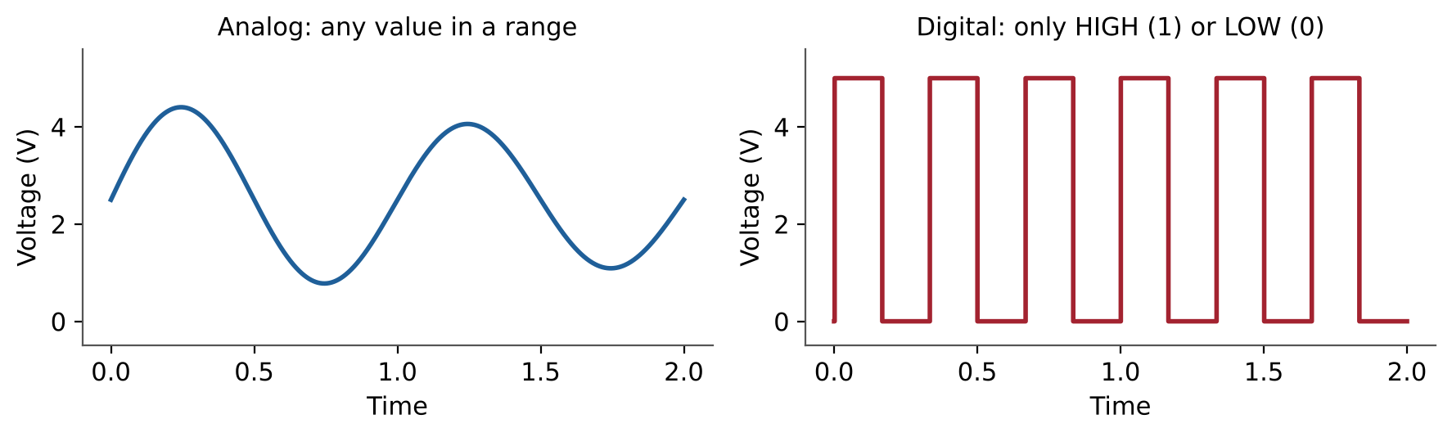
Figure 4.1: An analog signal compared with a digital signal.

4.2 Number Systems
Digital circuits represent numbers in binary (base 2), where each digit, called a bit, is 0 or 1. Each bit position has a place value that doubles from right to left: 1, 2, 4, 8, 16, 32, 64, 128. Eight bits form a byte, which can represent 256 values (0–255). Hexadecimal (base 16) is a compact way of writing binary, with one hex digit standing for four bits.
Decimal | Binary | Hexadecimal
5 | 0000 0101 | 05
10 | 0000 1010 | 0A
13 | 0000 1101 | 0D
200 | 1100 1000 | C8
255 | 1111 1111 | FF

An n-bit number can represent 2ⁿ different values. A 10-bit number therefore spans 0–1023 and a 12-bit number spans 0–4095, which is exactly the range of values an ADC of that size produces (Section 6).

4.3 Logic Levels
A digital input does not see the voltage itself; it sees whether the voltage falls within the HIGH or LOW band. For 74HC-series logic powered at 5 V, an input above 3.5 V is a valid HIGH and an input below 1.5 V is a valid LOW. Voltages in between are undefined and may be read either way. Devices powered at 3.3 V use lower thresholds and may be damaged by a 5 V signal.
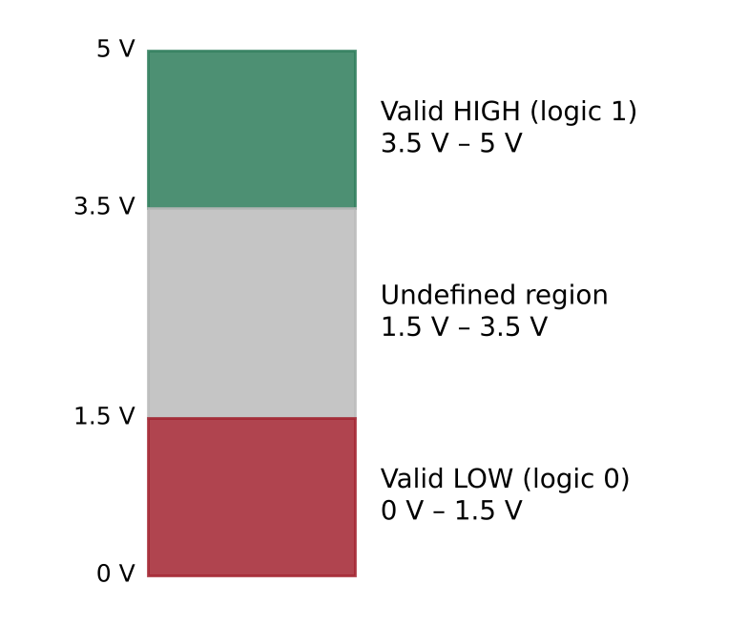
Figure 4.2: Logic-level bands for 5 V 74HC-series logic.
An input that is not connected to anything is said to be floating. It picks up electrical noise and changes state randomly. A pull-up resistor (to the supply) or pull-down resistor (to ground) gives every input a defined default state.

4.4 Logic Gates and Truth Tables
A logic gate is a circuit that produces a digital output according to a fixed rule applied to its inputs. The rule is fully described by a truth table that lists every combination of inputs. Inside, every gate is built from transistors, which are introduced in Section 7.
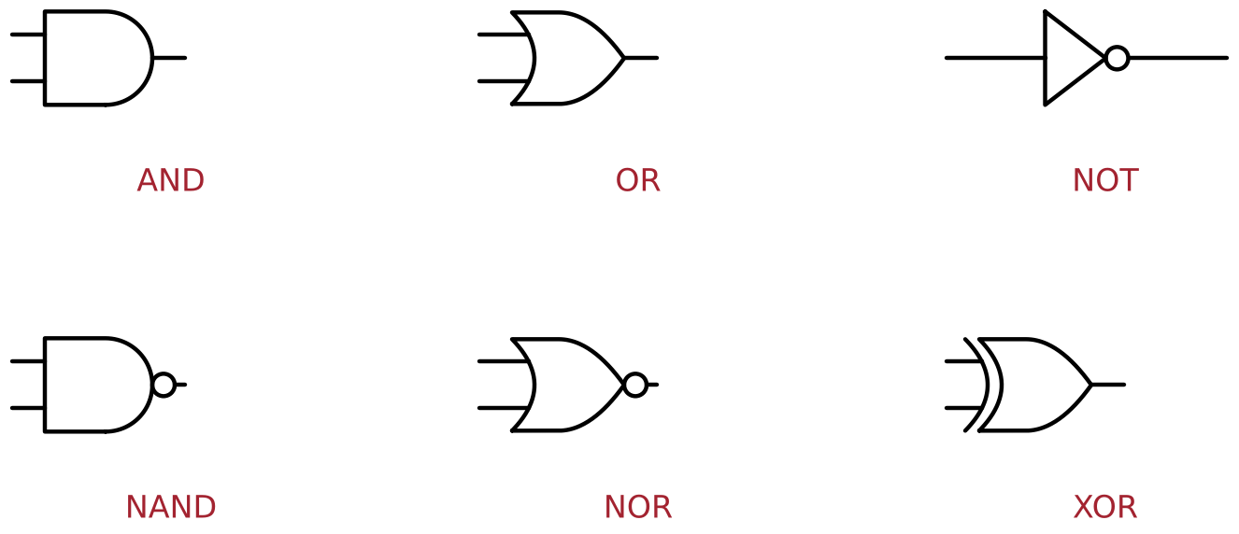
Figure 4.3: Standard symbols of the six basic logic gates.
A | B | AND | OR | NAND | NOR | XOR
0 | 0 | 0 | 0 | 1 | 1 | 0
0 | 1 | 0 | 1 | 1 | 0 | 1
1 | 0 | 0 | 1 | 1 | 0 | 1
1 | 1 | 1 | 1 | 0 | 0 | 0

- AND — the output is 1 only when all inputs are 1 (like a door with two locks).
- OR — the output is 1 when any input is 1 (like a room with two doors).
- NOT — the output is the opposite of the input.
- NAND and NOR — AND and OR followed by NOT. NAND is called a universal gate, because every other gate can be built from NAND gates alone.
- XOR — the output is 1 when the inputs are different.

4.5 Boolean Logic and Combinational Design
Boolean algebra is the mathematics of logic. AND is written as multiplication (A·B), OR as addition (A + B), and NOT with a bar or apostrophe (A'). A written requirement can be converted into a circuit in four steps: describe it in words, write the truth table, express it as a Boolean equation, and implement it with gates.
Worked example — safety interlock. A fan may run only if the safety guard is closed (S) AND either the automatic temperature demand (T) OR the manual switch (M) requests it. The Boolean equation is:
FAN = S · (T + M)
This is built from one OR gate feeding one AND gate. Because the rule is implemented in hardware, the fan stays off when the guard is open even if the software makes a mistake. This interlock forms the decision stage of the Smart Sensor Node.

5. Analog Electronics & Sensors as Analog Devices

5.1 Properties of an Analog Signal
An analog signal is described by its range (minimum and maximum values), its offset (the value when the measured quantity is zero), its sensitivity (how much the signal changes per unit of the measured quantity), and its noise (random variation unrelated to the measurement). A good sensor interface uses as much of the available measurement range as possible and keeps noise much smaller than the changes of interest. The ratio between signal and noise is called the signal-to-noise ratio (SNR).

5.2 Diodes and LEDs
A diode allows current to flow in one direction only. It begins to conduct once the forward voltage across it exceeds a threshold, about 0.6–0.7 V for a silicon diode. Above that threshold, the current rises very steeply, so a diode or LED must always have a series resistor to limit current.
A light-emitting diode (LED) emits light when it conducts. Its forward voltage depends on its colour: about 1.8–2.0 V for red, 2.0–2.2 V for green, and 2.8–3.2 V for blue and white. Diodes are also used for protection, as the flyback diode in Section 8 shows.
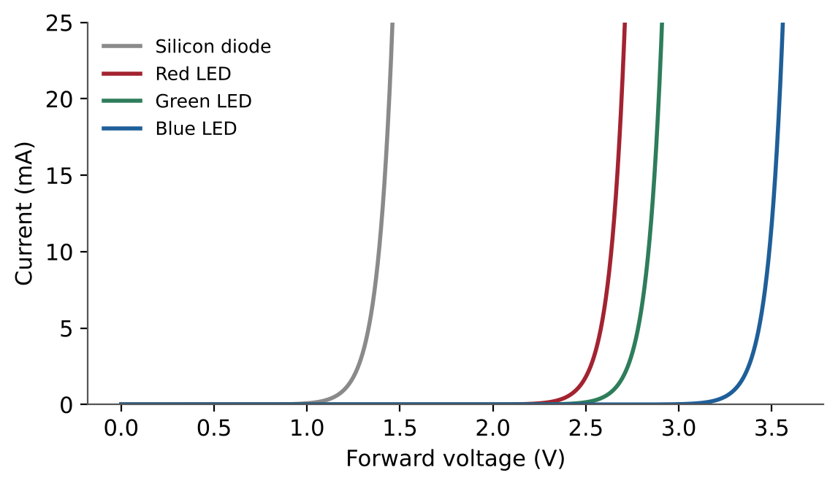
Figure 5.1: Current–voltage (I–V) characteristics of a silicon diode and LEDs of different colours.

5.3 What Is a Sensor?
A sensor is a device that converts a physical quantity into an electrical signal. Most sensors are analog devices: their output changes smoothly with the quantity they measure. Sensors can be grouped by how they produce that signal.
Sensor Type | Example | Measured Quantity | Electrical Output
Resistive | LDR (photoresistor) | Light | Resistance falls as light rises
Resistive | NTC thermistor | Temperature | Resistance falls as temperature rises
Resistive | Potentiometer | Position/angle | Variable resistance ratio
Active (voltage output) | TMP36 | Temperature | Voltage proportional to temperature
Photodiode/image sensor | Camera pixel | Light intensity | Current or voltage per pixel

5.4 Resistive Sensors in a Voltage Divider
A resistive sensor changes its resistance, but a measuring circuit needs a voltage. The solution is to place the sensor in a voltage divider (Section 2.5) together with a fixed resistor. As the sensor's resistance changes, the divider's output voltage changes with it.
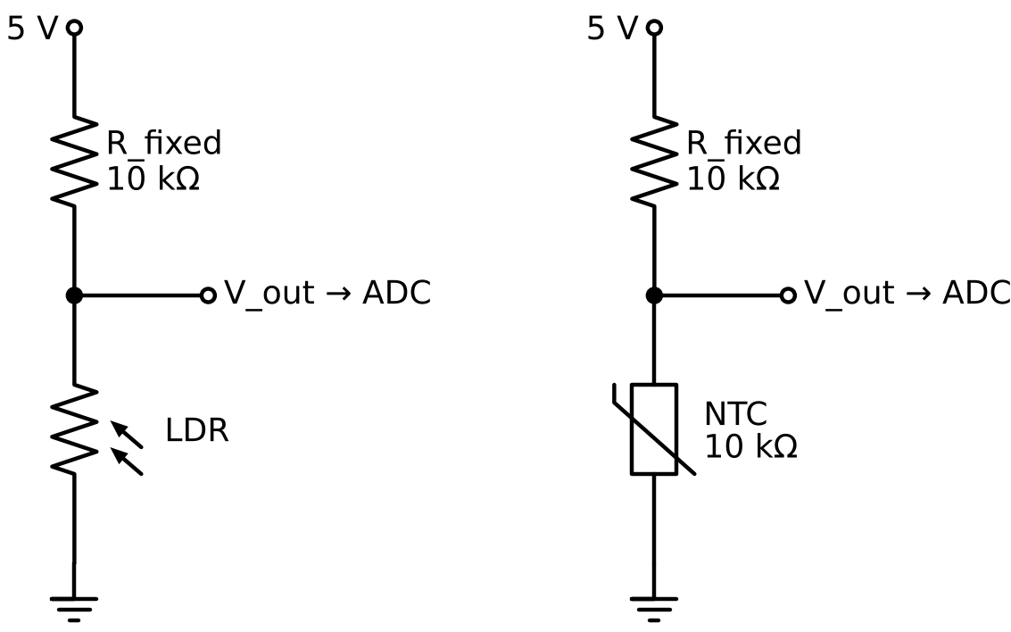
Figure 5.2: An LDR and an NTC thermistor, each connected in a voltage divider.

- LDR (Light Dependent Resistor) — its resistance is high in darkness (hundreds of kilo-ohms) and low in bright light (a few hundred ohms to a few kilo-ohms).
- NTC thermistor — its resistance decreases as temperature increases. A common type is 10 kΩ at 25 °C.
- Choosing the fixed resistor — the greatest sensitivity is obtained when R_fixed ≈ √(R_min × R_max) over the range of interest.
- Orientation — swapping the sensor and the fixed resistor inverts the response, so a rising quantity produces a falling voltage.
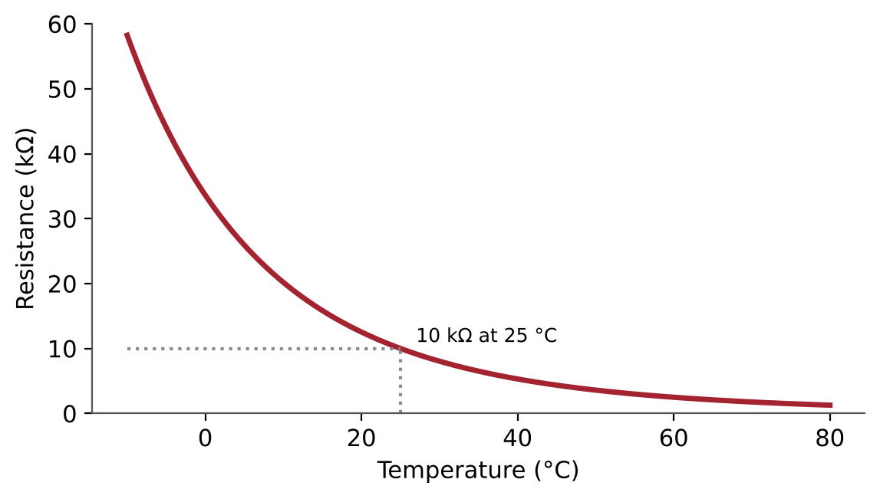
Figure 5.3: Resistance of a 10 kΩ NTC thermistor (B = 3950) versus temperature.
The thermistor's relationship is not linear. It is commonly described by the Beta equation, where T is in kelvin, R₀ is the resistance at T₀ = 298.15 K (25 °C), and B is a constant given in the datasheet:
1/T = 1/T₀ + (1/B) × ln(R/R₀)

5.5 Active Sensors: The TMP36
Some sensors contain their own electronics and directly output a voltage that is proportional to the measured quantity. The TMP36 temperature sensor outputs 0.5 V at 0 °C and adds 10 mV for every degree Celsius. It is linear and easy to use, but it still has small offset and gain errors.
V_out = 0.5 V + (0.01 V/°C) × T
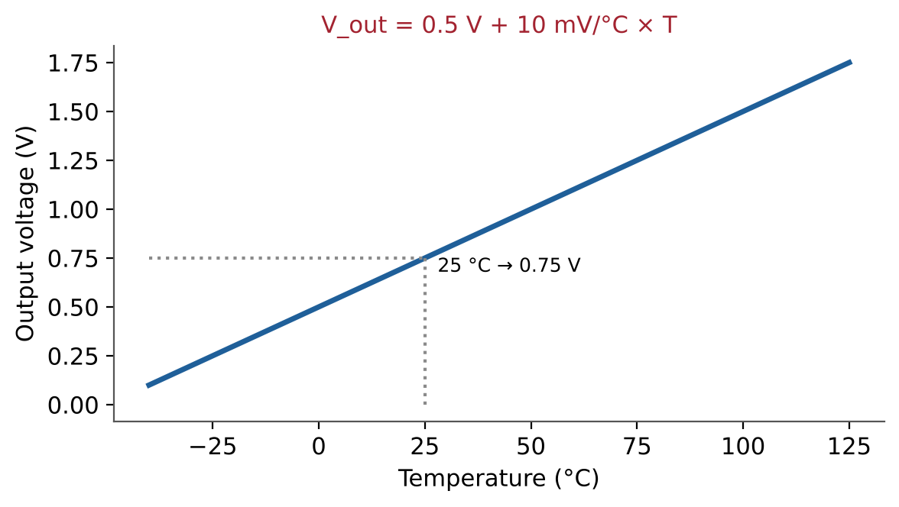
Figure 5.4: Output voltage of the TMP36 temperature sensor across its operating range.

5.6 Calibration
Every real sensor deviates slightly from its ideal equation. Offset error shifts every reading by the same amount; gain error makes the slope slightly too steep or too shallow. Calibration compares sensor readings with a trusted reference at known points. A two-point calibration (for example, in ice water at 0 °C and at room temperature measured with a reference thermometer) corrects both offset and gain. Calibration turns a sensor reading into a trustworthy measurement.

6. The ADC Concept

6.1 Why an ADC Is Needed
Sensors produce analog voltages, but processors work only with numbers. An analog-to-digital converter (ADC) measures an input voltage and outputs a number that represents it. The ADC is the bridge between the physical world and software, and it is present in every microcontroller, digital camera, microphone, smartwatch, and Edge AI device.
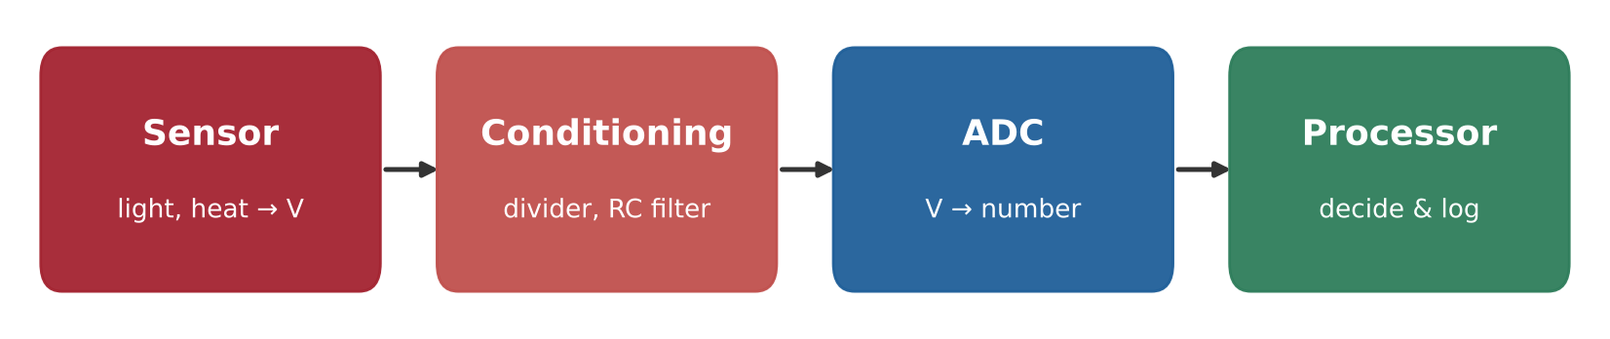
Figure 6.1: The signal chain from sensor to processor.

6.2 Sampling
An ADC does not watch a signal continuously; it takes snapshots called samples at regular intervals. The number of samples per second is the sampling rate. According to the Nyquist principle, a signal must be sampled at more than twice its highest frequency to be represented correctly; in practice, five to ten times is preferred. Room temperature changes slowly and needs only about one sample per second, while sound requires tens of thousands of samples per second.

6.3 Quantisation and Resolution
Each sample must be rounded to one of a fixed number of levels; this rounding is called quantisation. An n-bit ADC has 2ⁿ levels. The size of one step is called the least significant bit (LSB), and it sets the smallest voltage change the ADC can detect.
Digital code = V_in / V_ref × (2ⁿ − 1) LSB = V_ref / 2ⁿ
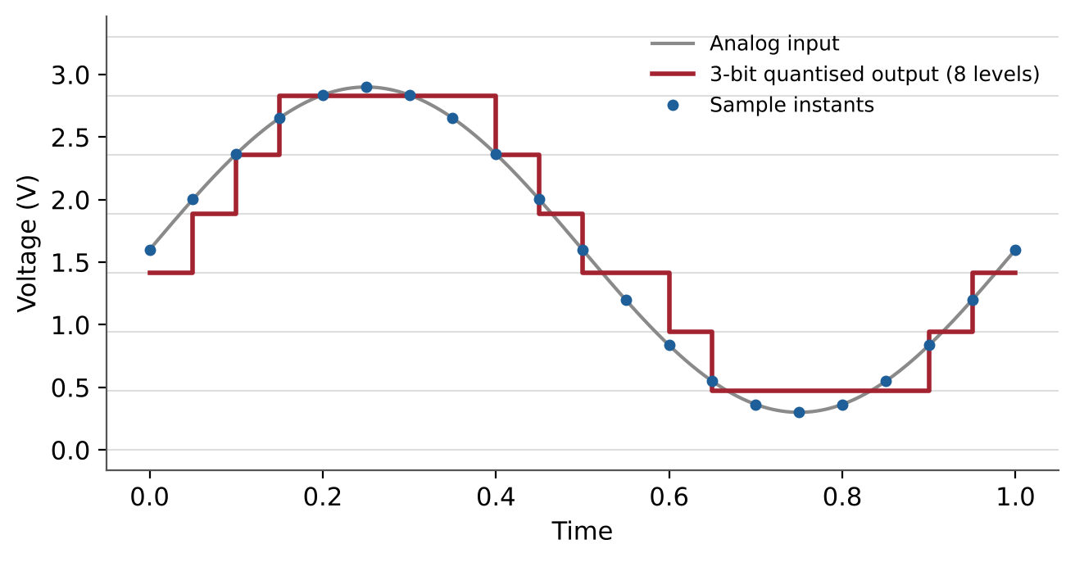
Figure 6.2: Sampling and quantisation of an analog signal by a 3-bit (8-level) ADC.
ADC Resolution | Number of Levels | LSB at 5 V | LSB at 3.3 V
8-bit | 256 | 19.5 mV | 12.9 mV
10-bit | 1024 | 4.88 mV | 3.22 mV
12-bit | 4096 | 1.22 mV | 0.81 mV
14-bit | 16384 | 0.31 mV | 0.20 mV

Worked example. A 10-bit ADC with a 5 V reference reads a TMP36 sensor. One LSB is about 4.9 mV, and the sensor changes by 10 mV per °C, so each count represents about 0.49 °C. If a reading of 153 counts is obtained, the voltage is 153 × 5 / 1023 ≈ 0.75 V, which corresponds to 25 °C.

6.4 The Reference Voltage
The reference voltage (V_ref) is the input voltage that produces the maximum digital code. Every conversion is calculated relative to it, so an incorrect assumption about V_ref scales every reading wrongly. For example, if a program assumes a 3.3 V reference while the ADC actually uses 5 V, every reading will appear about 34% too low. A stable, accurately known reference is essential for accurate measurement.

6.5 Resolution Versus Accuracy
Resolution is the smallest step an ADC can show; accuracy is how close the reading is to the true value. A ruler with fine millimetre markings is still wrong if it was printed 2% too long. ADC accuracy is limited by offset error, gain error, non-linearity, reference error and noise, so the true accuracy of a system is always worse than its resolution.

6.6 Noise and Averaging
Repeated readings of a perfectly steady voltage are rarely identical; they vary by a few counts because of electrical noise. Averaging N readings reduces random noise by approximately the square root of N. Averaging 16 samples reduces noise by about a factor of four. The trade-off is speed: heavy averaging slows the response to real changes.
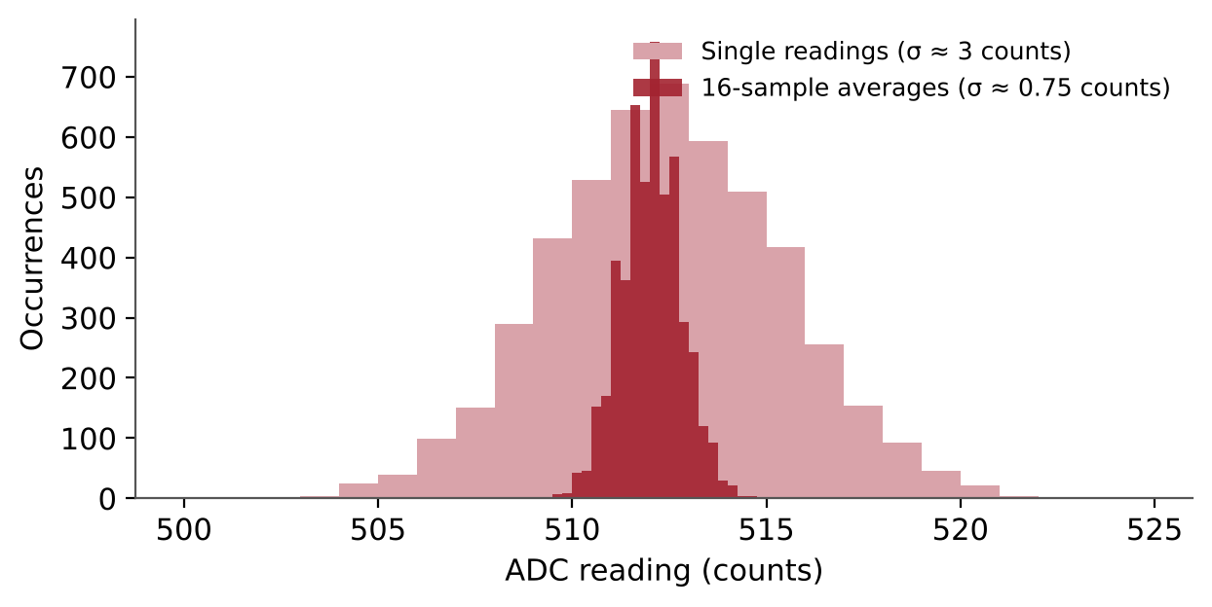
Figure 6.3: Distribution of single ADC readings compared with 16-sample averages.

6.7 Types of ADC
ADC Architecture | Speed | Resolution | Typical Use
Successive Approximation (SAR) | Medium–high | 8–18 bit | Microcontrollers, general sensing
Sigma-Delta (ΣΔ) | Low–medium | 16–24 bit | Precision measurement, audio, weighing scales
Flash | Very high | 6–8 bit | Oscilloscopes, high-speed video
Pipelined | High | 10–16 bit | Communications, image sensors

6.8 From Sensor Readings to Images
A digital camera sensor is a grid of millions of tiny light sensors (photodiodes), each read by an ADC. The resulting grid of numbers is an image. If a single light sensor is moved across an 8 × 8 grid and its readings are stored, the result is a tiny image in which each pixel is one ADC value. This shows the direct link between the concepts in this module and the fields of image processing and computer vision, which operate on exactly these grids of numbers.
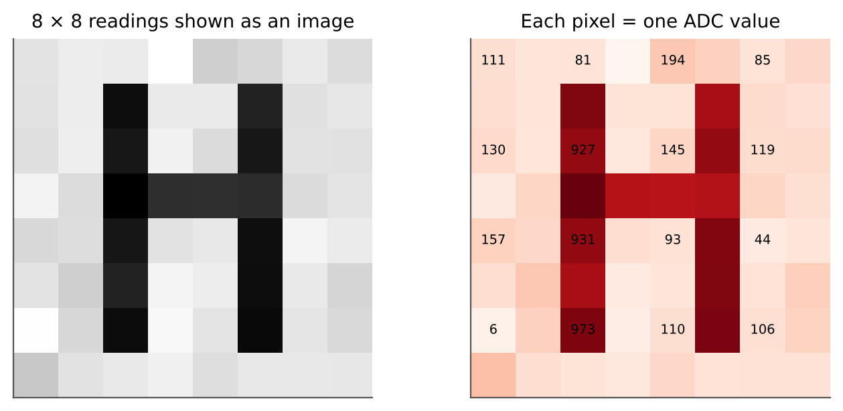
Figure 6.4: Light readings from an 8 × 8 grid displayed as an image; each pixel is one ADC value.
Lab Exercise 3: Reading and Calibrating an Analog Temperature Sensor
Objective
To understand how an analog sensor voltage is converted by an ADC into a digital value, and to convert that value into a calibrated temperature reading.
Components Required
- TMP36 temperature sensor
- Microcontroller board with a 10-bit ADC (for example Arduino Uno)
- 100 nF decoupling capacitor
- Reference thermometer and a glass of ice water
Working Principle
The TMP36 produces a voltage proportional to temperature. The ADC converts this voltage into a digital code relative to its reference voltage. Using the ADC equation and the sensor equation, each digital code can be converted first into volts and then into degrees Celsius. Comparison with a reference thermometer reveals offset and gain errors, which a two-point calibration removes.
Procedure
- Connect the TMP36 to 5 V, ground and an analog input, with a 100 nF capacitor across its supply pins.
- Calculate the LSB size and the temperature represented by one ADC count.
- At room temperature, record the ADC code, convert it to volts and then to °C, and note the reference thermometer reading.
- Place the sensor (protected in a sealed bag) in ice water and repeat the measurement.
- Use the two reference points to calculate the corrected offset and slope.
- Apply the correction to a third reading and compare the result with the reference thermometer.
Observation Table
Condition | ADC Code | Voltage (V) | Sensor Temp. (°C) | Reference Temp. (°C) | Error (°C)
Room temperature
Ice water
After calibration

Expected Output
Before calibration, readings may differ from the reference by one or two degrees. After two-point calibration, the error should fall to within about ±1 °C, limited mainly by the ADC resolution of about 0.49 °C per count.
Conclusion
This activity demonstrates the complete path from a physical quantity to a trustworthy number: sensor, voltage, ADC code, engineering units and calibration.

7. Transistors

7.1 Why Transistors Are Needed
A microcontroller output pin can safely supply only a few milliamperes (often less than 10 mA), while motors, fans, lamps and relays need hundreds of milliamperes or more. A transistor is a semiconductor device that lets a small control signal switch or amplify a much larger current. Transistors are also the building blocks of every logic gate, memory chip and processor: a modern processor contains billions of them.

7.2 The Bipolar Junction Transistor (BJT)
A BJT has three terminals: base (B), collector (C), and emitter (E). In an NPN transistor, a small current flowing into the base allows a much larger current to flow from collector to emitter. The ratio between them is the current gain, β (or h_FE), typically 100–300.
I_C = β × I_B
Region | Base Condition | Behaviour | Used For
Cut-off | No base current | Switch OFF — no collector current | Digital switching (OFF)
Active | Moderate base current | I_C proportional to I_B | Amplifiers
Saturation | Ample base current | Switch fully ON — V_CE ≈ 0.2 V | Digital switching (ON)

7.3 The BJT as a Switch
To use a BJT as a switch, it is driven between cut-off and saturation. To guarantee saturation, the base current is chosen to be about one tenth of the collector current, regardless of the transistor's actual gain. The base resistor is then:
R_B = (V_GPIO − 0.7 V) / I_B with I_B ≈ I_C / 10
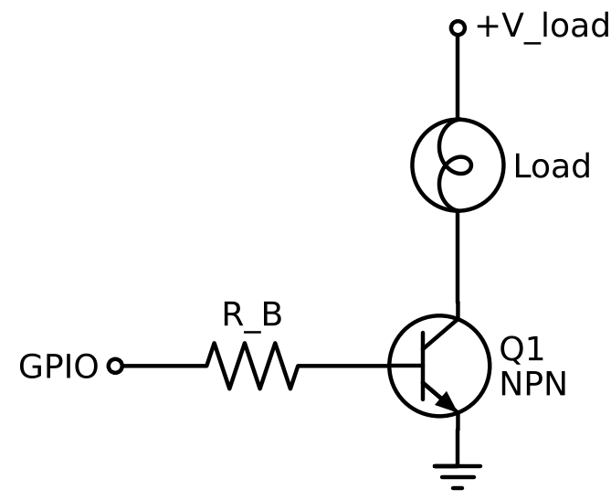
Figure 7.1: An NPN transistor used as a low-side switch controlled by a microcontroller pin.
Worked example. A load draws 70 mA from a 5 V supply and is controlled by a 5 V pin. Choosing a base resistor of 1 kΩ gives I_B = (5 − 0.7) / 1000 ≈ 4.3 mA, which is safe for the pin and provides a forced gain of about 16, enough to saturate a 2N2222 transistor.

7.4 The MOSFET
A MOSFET (Metal-Oxide-Semiconductor Field-Effect Transistor) has a gate (G), drain (D) and source (S). Unlike a BJT, it is controlled by voltage rather than current: once the gate-to-source voltage exceeds a threshold, the channel between drain and source conducts with a very low resistance, R_DS(on). Almost no steady gate current is required.
- Logic-level MOSFETs (such as the IRLZ44N) are designed to turn fully on with a gate voltage of about 5 V or lower.
- A small gate resistor (about 100–220 Ω) limits the brief charging current of the gate.
- A pull-down resistor (about 100 kΩ) from gate to source keeps the MOSFET off while the controller is starting up.
- Heat dissipated in the MOSFET is P = I² × R_DS(on), which is very small for a well-chosen part.
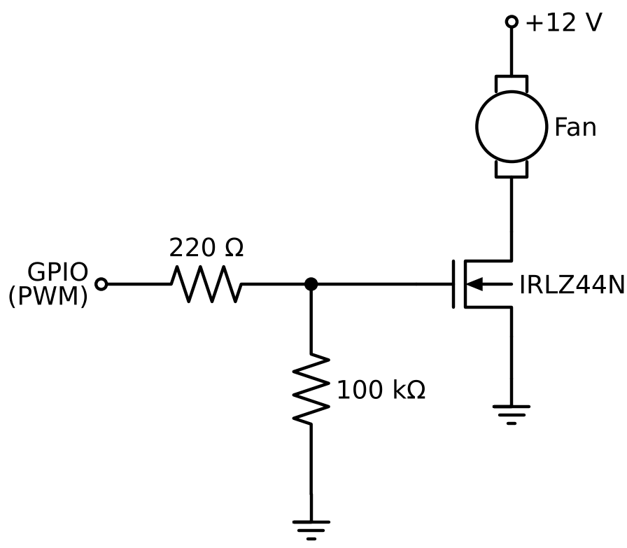
Figure 7.2: A logic-level N-channel MOSFET switching a DC fan.
Feature | BJT | MOSFET
Controlled by | Base current | Gate voltage
Drive power needed | Continuous base current | Almost none (only to charge the gate)
Voltage drop when ON | V_CE(sat) ≈ 0.2 V | I × R_DS(on), often a few millivolts
Best suited for | Small loads, simple circuits | Higher currents, PWM, efficiency

7.5 Pulse-Width Modulation (PWM)
A transistor switch is either on or off, yet it can still control the average power delivered to a load. Pulse-width modulation switches the load on and off rapidly; the fraction of each cycle spent on is the duty cycle. A 25% duty cycle on a 5 V supply delivers an average of 1.25 V. PWM is used to control motor speed, LED brightness and heater power efficiently, because the transistor spends almost no time in its lossy middle state.
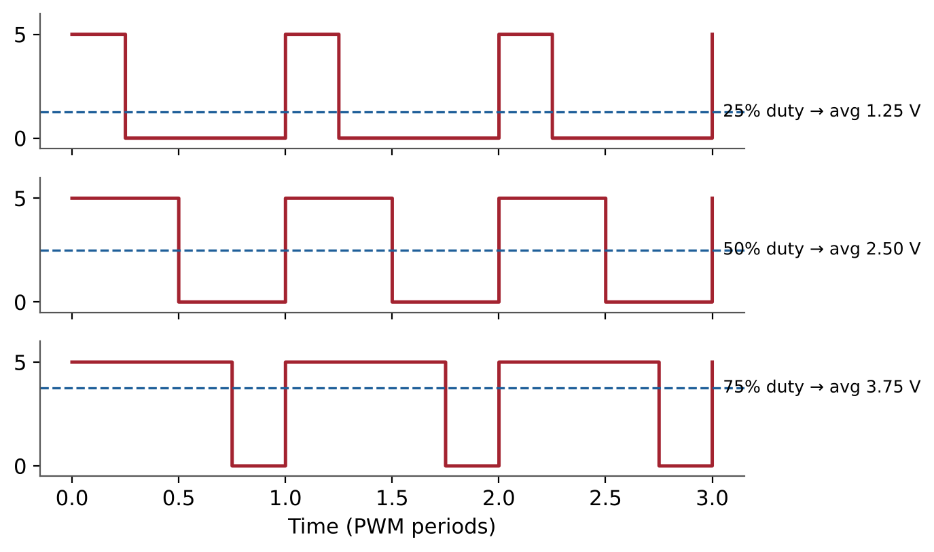
Figure 7.3: PWM signals at 25%, 50% and 75% duty cycle and their average voltages.

8. Relays

8.1 What Is a Relay?
A relay is an electrically operated switch. It contains a coil of wire wound around an iron core. When current flows through the coil, it becomes an electromagnet and pulls a movable metal arm, the armature, which opens or closes a set of contacts. The control circuit (the coil) and the load circuit (the contacts) are electrically separated, so a low-voltage signal can safely control a completely different circuit.
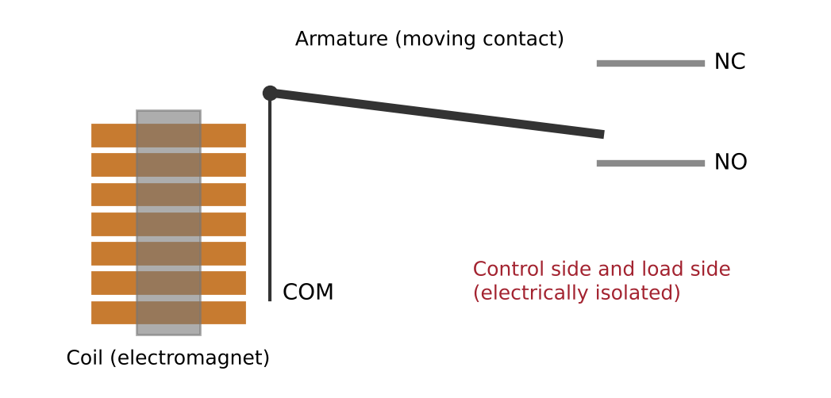
Figure 8.1: Internal construction of an electromechanical relay.

8.2 Relay Contacts
Terminal | Name | State When Coil Is OFF | State When Coil Is ON
COM | Common | Moving contact | Moving contact
NC | Normally Closed | Connected to COM | Disconnected
NO | Normally Open | Disconnected | Connected to COM

Important ratings in a relay datasheet are the coil voltage (for example 5 V), the coil current (often 70–90 mA for small 5 V relays), and the maximum contact voltage and current. Because the coil current exceeds what a microcontroller pin can supply, a relay is always driven through a transistor.

8.3 The Flyback Diode
A relay coil is an inductor, and an inductor resists sudden changes in current. When the transistor switches the coil off, the collapsing magnetic field generates a large reverse voltage spike that can reach tens or hundreds of volts. This spike can destroy the transistor or reset the microcontroller.
A flyback diode connected across the coil (cathode to the positive supply) gives this current a safe path to circulate and decay. It does not conduct during normal operation, only during the spike. Ready-made relay modules include this diode, but understanding why it is needed is essential for designing any circuit that switches a coil, motor or solenoid.
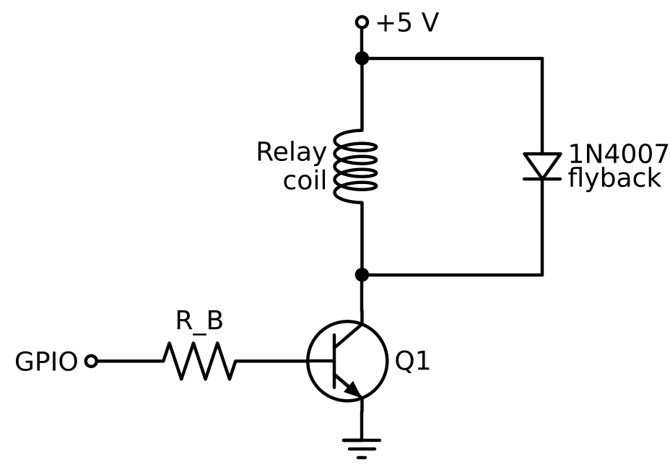
Figure 8.2: Transistor relay driver with a flyback diode across the coil.

8.4 Relay or Transistor?
Feature | Relay | Transistor / MOSFET
Isolation between control and load | Yes (galvanic) | No (shared ground)
Can switch AC loads | Yes | Not directly
Switching speed | Slow (milliseconds) | Very fast (microseconds)
Suitable for PWM | No | Yes
Lifetime | Limited mechanical cycles | Effectively unlimited
Audible click | Yes | Silent

8.5 Driver Design Checklist
- Identify the load voltage and current from its datasheet.
- Choose a switching device rated for at least twice the load voltage and current.
- Calculate the base resistor (BJT) or select a gate resistor (MOSFET).
- Add a pull-down resistor so the load stays off during start-up.
- Fit a flyback diode across every inductive load (relays, motors, solenoids).
- Connect the grounds of the control and load supplies together (except across a relay's isolated contacts).
- Check heat dissipation in the switching device.
Lab Exercise 4: Driving a Relay with a Transistor
Objective
To understand how a low-current control signal switches a relay through a transistor, and to explain the role of the flyback diode in protecting the circuit.
Components Required
- 5 V relay (coil current about 70 mA)
- 2N2222 NPN transistor and 1 kΩ base resistor
- 1N4007 diode
- 5 V DC supply, 5 V fan or lamp as the load, push-button
- Digital multimeter
Working Principle
A small base current switches the transistor into saturation, allowing the relay coil current to flow. The energised coil pulls the armature and closes the NO contact, switching the load. When the base current is removed, the transistor turns off and the flyback diode safely absorbs the energy released by the coil.

Procedure
- Read the relay datasheet and note the coil voltage, coil current and contact ratings.
- Calculate the base current and base resistor needed to saturate the transistor.
- Connect the coil between +5 V and the transistor's collector, and the emitter to ground.
- Connect the flyback diode across the coil with its cathode to +5 V.
- Wire the load through the relay's COM and NO contacts.
- Apply the control signal and observe the relay operation and the load.
- Measure V_CE with the transistor on and confirm that it is in saturation.
Observation Table
Quantity | Calculated Value | Measured Value
Base current I_B | ≈ 4.3 mA
Coil current I_C | ≈ 70 mA
V_CE when ON | ≈ 0.2 V
Load state (control HIGH / LOW) | ON / OFF

Expected Output
When the control signal is applied, the relay clicks and the load switches on; when it is removed, the load switches off. V_CE should be about 0.2 V when the transistor is on, confirming saturation.
Conclusion
This activity shows how transistors and relays together convert a low-power decision into the switching of a real load, with the flyback diode providing essential protection.

9. Bringing It Together: The Smart Sensor Node

9.1 System Overview
Each section of this module explains one stage of a complete electronic system. The Smart Sensor Node combines them to keep a small room or enclosure from overheating:
Stage | Function | Concepts Used | Section
Power and status | Supply rail and status LED | Ohm's law, current-limiting resistor | 2
Clean inputs | Stable button and sensor signals | RC filtering, debouncing, decoupling | 3
Safety logic | Hardware interlock | Logic gates, Boolean design | 4
Sensing | Light and temperature measurement | LDR, NTC, TMP36, voltage divider | 5
Conversion | Voltages turned into numbers | ADC, resolution, averaging | 6
Actuation | Fan or lamp switching | Transistor, MOSFET, relay, flyback diode | 7–8

9.2 Hysteresis
If a fan is switched on above 30 °C and off below 30 °C, small amounts of noise near 30 °C will make the relay switch on and off rapidly, a fault known as chattering. Hysteresis solves this by using two thresholds: the fan switches on above 30 °C and switches off only below 28 °C. Between the two thresholds the system keeps its previous state. Household thermostats work on exactly this principle.
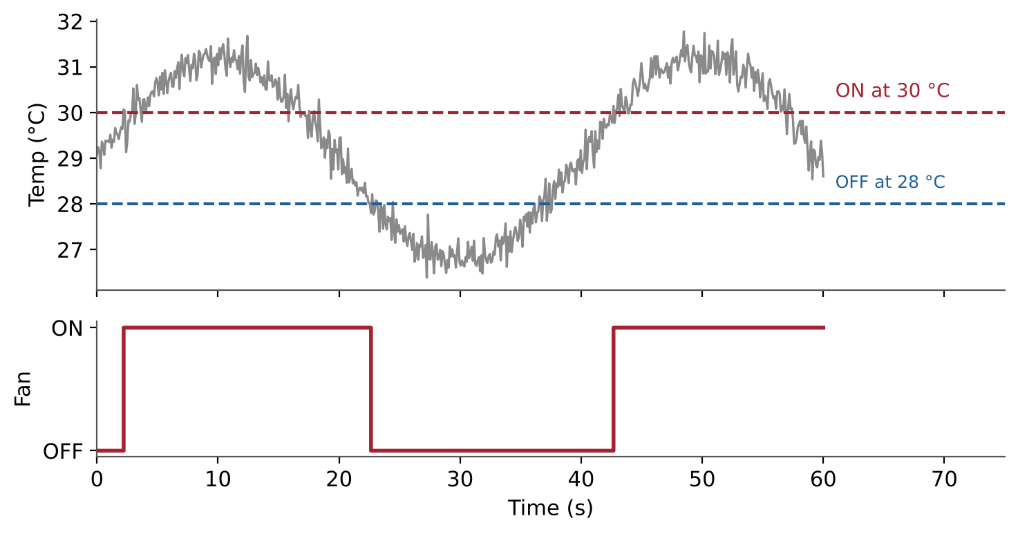
Figure 9.1: Hysteresis control: two thresholds prevent rapid switching caused by noise.

9.3 From Sensor Data to Edge AI
Once sensor readings are converted into numbers, they can be stored and analysed as data. Instead of writing every decision rule by hand, a small machine-learning model can learn rules from labelled examples, for instance recognising whether a room is dark, normally lit or in direct sunlight from features such as the average and variation of light readings over a few seconds. This is pattern recognition.
When a trained model runs directly on the device next to the sensor, rather than in the cloud, the approach is called Edge AI. Computer vision applies the same idea to images, which, as Section 6.8 explained, are simply large grids of ADC values from light sensors. The foundations in this module — sensors, signal conditioning, and analog-to-digital conversion — are therefore the starting point of every intelligent embedded and vision system.
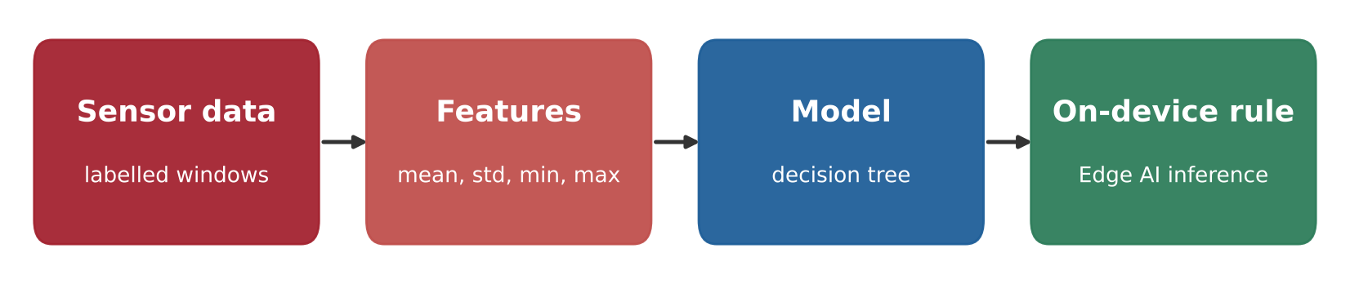
Figure 9.2: The Edge AI pipeline: sensor data, features, a trained model and on-device decisions.

9.4 Summary
Electronics can be understood as a chain: sensors turn the physical world into voltages, resistors and capacitors shape and protect those voltages, the ADC turns them into numbers, digital logic makes decisions, and transistors and relays act on those decisions. Mastering each link in this chain prepares the learner for embedded systems, robotics, the Internet of Things, and Edge AI.

